React js
Imp
Component
Props
States [use state, use effect, use Ref, use Context] this are hooks
Routing

React was developed by Facebook in year 2013 and they had millions of users and they were maintaining dynamic data which is its different for everyone and it keeps on changing so react is used to develop and maintain the dynamic data in the form of component based where we will only reload which is necessary and not a whole page
What is react
React js is a library or a framework which is developed based on component based architecture, created by facebook to handle large amount of dynamic data
React js is both framework and library
- Framework: framework is blueprint or a template available to perform some functions or task
- Library: library are predefined, inbuilt already available, accessing the inbuilt function, usage of library is very less now, earlier react js was library and then it was both framework and library as well
Why both and when do we make use of this framework and library
For small scale we will be using libraries if we want to develop a large scale we will use framework
imp
- Single page application: single page we will not have multiple page but we will be having 1 single page it has only 1 html page
- React js is both framework and library
- Component based architecture: react is a component based architecture , in a web page each and every section is divided into components
In multi page : while accessing the pages it will reload whole page
In single page: while accessing the 1 component we can just reload what page we need
- Static and dynamic data: static is the content does not change and dynamic is content that updates over time without page refresh ex: mail
- Virtual Dom: React application will makes use of Virtual Dom, original dom creates a virtual dom automatically
Whenever the data is given to the original dom it will be given to the virtual dom

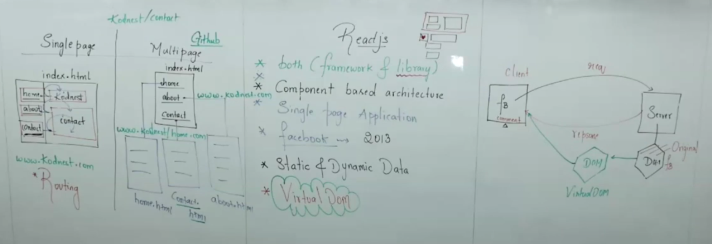

Create react app command is now deprecated
VITE React application to create projects
- npm create vite@latest firstapp (file name) enter // these are the commands used to create a application with the help of VITE we make use of these, npm is node package manager
- Npm run dev // used to run the project
As soon as we click the https://localhost:5174
It is connected to the browser We will get the o/p in the html page , and browser will load the o/p in html page as it will only understand the html page
Now inside the node-package we have @babel which is a compiler and it takes the react code as an i/p and produces the javascript code as an o/p
And we will have only 1 html file as index.html as react is a single page application.
React has the file name extention of filename.jsx which is the combination of the js and html / xml extended markup lang which is html and js
If we want to write our own code we will treat everything as an components
Component:
Component Is an individual piece of code in our web page, react component is a reusable piece of UI
And we have 2 types of components in react
- Functional component: we make use of functional component
- Class component: we don’t use anywhere its waste
The main react file is the main.jsx it loads the html file and inside html app is loaded, so what ever we need to represent the content page we need to represent in the browser page everything we need to write inside the app.jsx file

- Functional component
App.jsx

function App() { //js //the function name should be same as filename with capital
return(
<h1>Welcome to React</h1> //html
);
}

export default App;

App.jsx

Export default function App() { // JS - The function name should match the filename and start with a capital letter, here only u can give export , and ifu don’t want default you can remove but u need to add { } while importing
return (
<>
{/* Empty fragment wraps everything since React components must return a single element.
You could also use a <div> instead of <> </> */}
<h1>Welcome to React</h1> {/* HTML inside JSX */}
<p>Hello, How are you?</p>
</>
);
}
Short cut to create a function rfc enter

- Class component

App.jsx
Class App extends Component { // class acts a normal class , if we want to tell that App is a class component we need to make use of extends
render( ) {
return (
<div>
<h1> Destinty </h1>
</Home>
</div>
<h1>Thank you </h1>
)
}
}
Export default App;

Home.jsx
Class Home extends Componet {
Render (){
Return (
<h1>Home </h1>
)
}
}
Export default Home;
Short cut to create a class rce enter
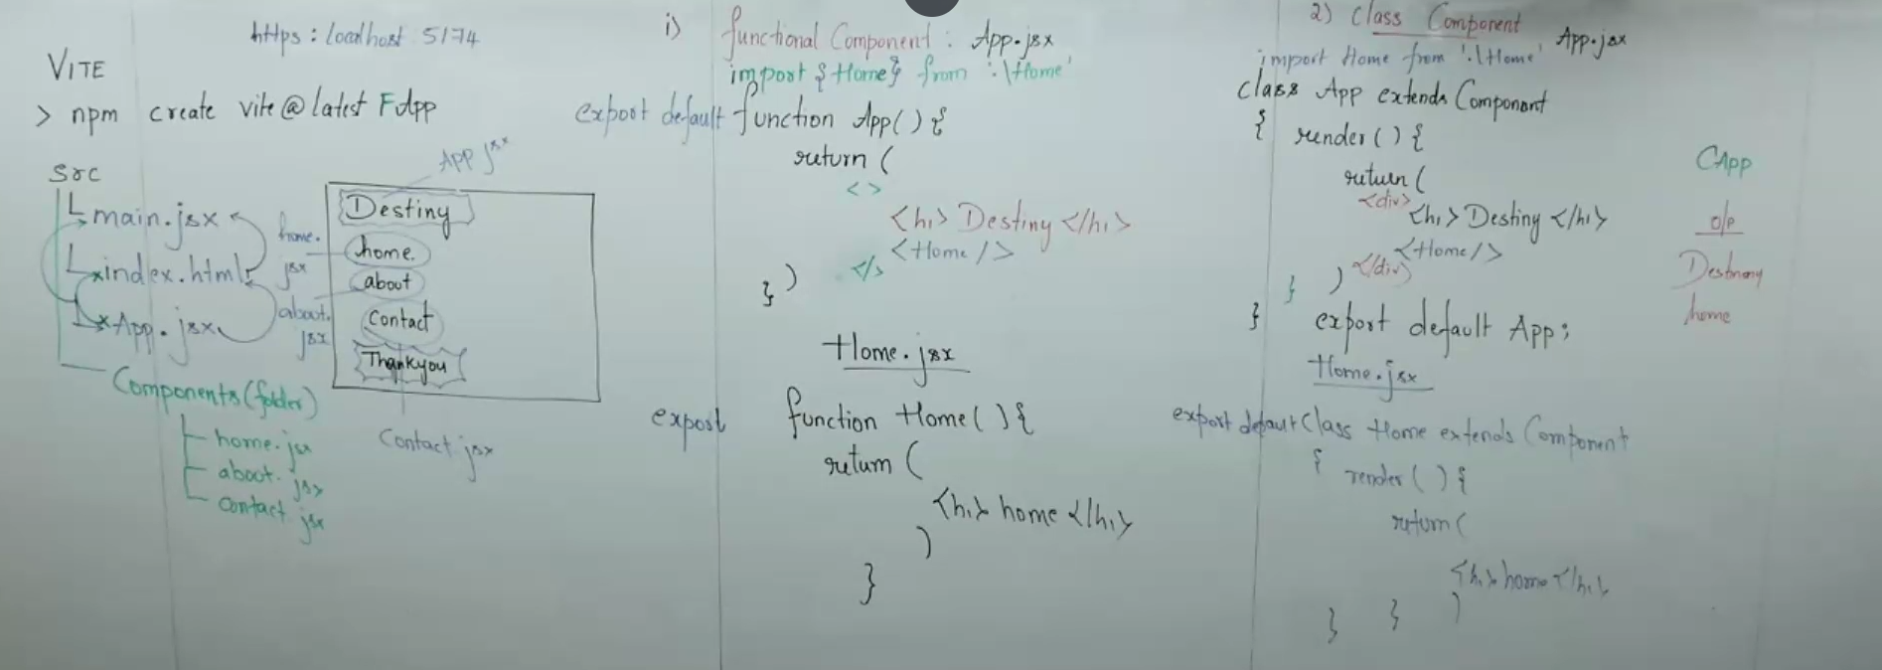

Props
Props are properties in short in order to set the behaviour of the components and this are passed from one component to another component, whenever we are passing in the props we pass in the form of key: value pair
And props can be passed from not only one to another but also from one to multiple components like we can pass from parent to child, parent we define is called as parent and the property which accepts is called as child. And a component can act as parent as well as child
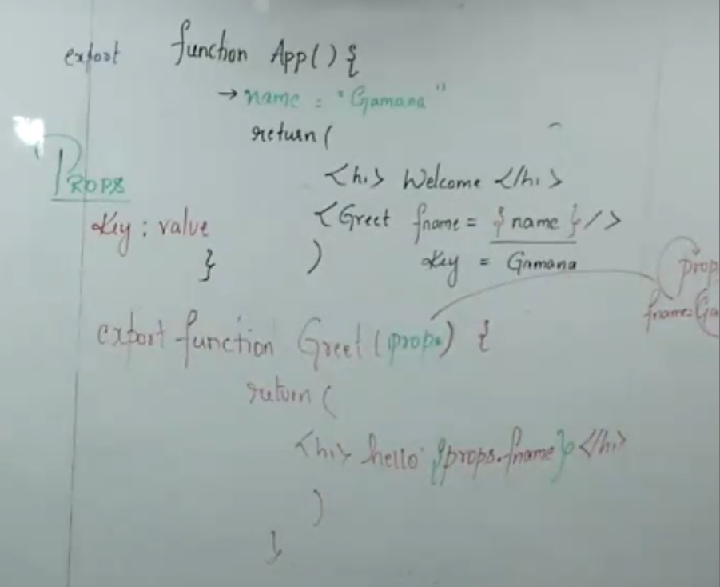
Code:
App.jsx

import Home from './component/Home.jsx';
import {About} from './component/About.jsx'; // as we are not using default in export we need to use { }
import Contact from './component/Contact.jsx';
import Greet from './component/Greeting.jsx';

function App() { // JS - The function name should match the filename and start with a capital letter
let name = "Rukmini";
let age = 22;
return (
<>
{/* Empty fragment wraps everything since React components must return a single element.
You could also use a <div> instead of <> </> */}
<h1>Welcome to React</h1> {/* HTML inside JSX */}
<Home/>
<About/>
<Contact/>
<Greet fname = {name} age = {age}/> {/* if just give name it will just point to name and if we want to get the value of name {name} we just give it in{}, and every time we pass it in key= value; pair itself so we give some name.
and fname = {name} is an arguments, so when ever we pass the arguments(is an props) to some particular function */}
</>
);
}

Greeting.jsx

// src/component/Greeting.jsx
import GreetCon from './GreetCon.jsx';

// props
export default function Greeting(props) {
return (
<div>
<h1>Hello {props.fname}, Age is : {props.age}</h1>
{/*and fname = {name} is an arguments, so when ever we pass the arguments to some particular function it acts as an props and we can fetch it like {props.fname} */}
<GreetCon n = {props.fname} /> {/*key value pair is must */}
</div>
);
}

GreetCon.jsx

//greeting contact
import React from 'react'

export default function GreetCon(props) {
return (
<div>
<h1> the contact name is {props.n} </h1> // if we make use of class then we will use this.props.n
</div>
)
}

export default App;

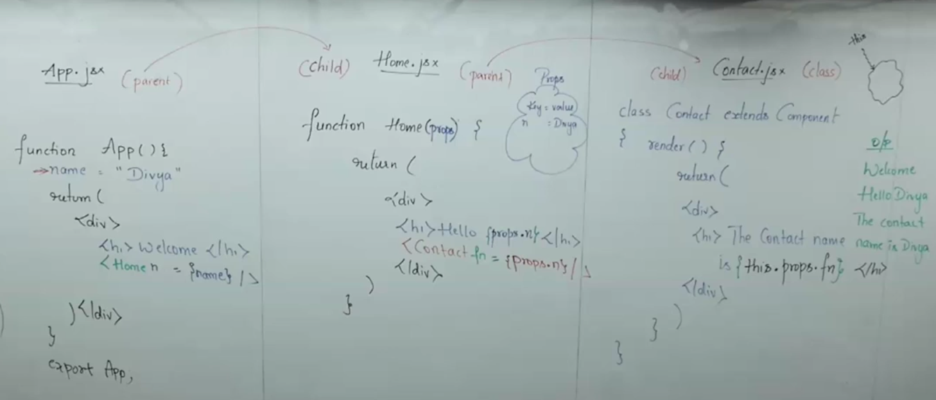

State
In react state is a special data that a component manages internally and can change over time, anything which changes with respect to the action that is state
When we declare a variable normally we can’t change it will be constant, if we want to change the value we need to declare it has state variable, how to make state variable is by using Hook (?) something like that so hooks are states which help to manage some component. It just link the state and component.

Just change the state of a variable we will be making use of use state Hook.

Usestate() in react
Any variable which is changing a state variable and they are declared with the hook called as UseState hook

import React, { useState } from 'react';

export default function Count() {
// let count =1; this we cant use because we ened the count to be incremented we cant keep that constant
let[count, setCount] = useState(1); // this wil accept the inital value which is 0 and let [count] is a name of the variablen and for perfoming the function we will name it as setCount which is a state Handler its a function
//datatype[variable,state handler] = useState(inital number);

//using normal function increment
function inc() {
setCount(count++); // so here setCount excepts a new value
}

//using arrow function decrement
let [sub,setSub] = useState(10);
// const dec = () => { can use this arrow function as well or directly pass it in the button itself
// setSub(sub = sub-1)
// }

//reset
const reset = () => {
setCount(1);
setSub(10);
}

//
let[mes,setMes] = useState(" "); //secret message dispaly

return (
<div>
<button onClick={inc}> Increment</button> {/*when i click a button it should perform the function inc*/}
<h1> Count is {count}</h1>

<br>
</br> {/*in react opening and closing is must */}
<br>
</br>

<button onClick={() =>setSub(sub-1)}>Decrement </button> {/*directly we can make like this insread of function*/}
<h1> sub is {sub}</h1>
<br>
</br>
<br>
</br>
<button onClick={reset} >Reset</button>
{/* or here also we can make use without arraow function
{() => {setCount(1);(setSub(10);}} */}

{/* secret message */}
<h1>{mes}</h1>
<button onClick={()=>{setMes("hello Arjun")}}>Click me</button>
</div>
);
}

// make use of arrow function in react because it is mostly used in react

UseEffect Hook
When ever you need to execute any task immediately automatically after execution of return statement, then we need to make use of useEffect, it’s like a side effect hook
ex: if ur fetching the data from backend how will u know is it fetched or not if it shows the notification u will know same way it is used to give notification once the function is executed.
In order to set cookies and close the file etc

//useEffecft hook
useEffect(()=>console.log("u clicked on a button")) //this will be execute only once after returing all the stataments

ex:
import React, { useState, useEffect } from 'react';

export default function AutoCount() {

let [counts, setCounts] = useState(0);

useEffect(() => {
const timer = setTimeout(() => {
setCounts(prev => prev + 1);
}, 1000);
});

return (
<div>
{/* automatically the count should increase like 1 2 3 */}
<h2>Your count is {counts}</h2>
</div>
);
}

Routing
To make the single page application as multipage application, Creating the URL with respect to the pages
And wht and all changes we make we will make in main only as it is only the parent of all the files in a project

Main.js
import { StrictMode } from 'react'
import { createRoot } from 'react-dom/client'
import { BrowserRouter } from 'react-router-dom'
import App from './App.jsx'
import './index.css'

createRoot(document.getElementById('root')).render(
<BrowserRouter> {/* browserrouter we need to give link for browserrouter, it will route wht ever the components we give it to the app.js */}
<StrictMode>
<App />
</StrictMode>
</BrowserRouter>,
)

App.jsx
import React from 'react'
import Navbar from './components/Navbar.jsx';
import Home from './components/Home.jsx';
import About from './components/About.jsx';
import Contact from './components/Contact.jsx';
import { Route,Routes } from 'react-router-dom'; //we need to import this because we are making use of routes and route

export default function App() {
return (
<div>
<h1> welcome to React Routing</h1>
<Navbar/>
<Routes>
<Route path="/" element ={<Home/>}></Route> {/* so here we have given the /, /About ryt that the url we have given in navbar that only we should give and the element is that from where we need to load so <Home/>*/}
<Route path="/About" element ={<About/>}></Route>
<Route path="/Contact" element ={<Contact/>}></Route>
</Routes>
</div>
)
}

Navbar.jsx
import React from 'react'
import {Link} from 'react-router-dom'

export default function Navbar() {
return (
<div>
{/* a href="url">home this is used as an anchor tag to link the files and all but in react we dont make use of this we make us of Link tage */}
<Link to='/'>Home</Link> {/*so here / will be in the same page*/}
<br>
</br>
<Link to='/About'>About</Link> {/* we have genreated the URL, now load the content in app.js */}
<br>
</br>
<Link to='/Contact'>Contact</Link>
</div>
)
}

Home.js
import React from 'react'

export default function Home() {
return (
<div>
<h2> This is Home component</h2>
</div>
)
}

About.jsx
import React from 'react'

export default function About() {
return (
<div>
<h2>This is About</h2>
</div>
)
}

Contact.jsx
import React from 'react'

export default function Contact() {
return (
<div>
<h2>This is Contact</h2>
</div>
)
}

Redux
Using props we cant directly share the data from parent to some other child class, it should be done only like parents should pass the data to his child and this child will become parent and it will share it to child like that ,and because of this which and all the child don’t want the data also it will hold. and this problem is called as “PROP DRILLING” –Important
Rules of props
When ever we need to pass the data we need to share it from parent to child itself u cant share it from parent to some other child, there should be link.
Prop drilling is passing the data from parent to child parent to child even though there is no use of data for some child is called as redux.
Redux
Redux is called as central state management library in order to manage state variable that is passed to a component.
Redux was introduced in order to over come with the prop drilling.
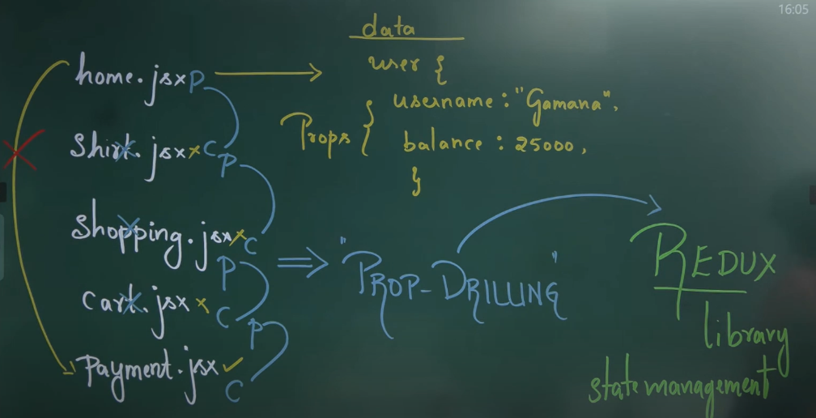
Instead of storing the user data in home.jsx we store it into store.js and can access to payment.jsx using hook- use selector hook.
Whenever we create a react project we need to install redux
In redux we have 3 states
Initial state
Action state
Reduce state
Initial state: in the initial state we have store.js which is username: gamana and balanace: 2500 to pass this to component of initial we make use of userinfo.js this need the user information like username and balance so we make use of use selector() hook and later we need to perform the action
From the initial state we go to the action state and action should consider 2 states
type of action: it has add or sub here we make use usedispatch hook in order to collect the action and put it into the button component
and payload action: it takes number like 500 or 600
And next we have reducer state which is a final state it accepts the initial state and action and reducer will reduce this function and give final o/p ex: it will take 25000 from initial and take + 500 from the action and adds it and gives the output as 25500 which is reduced

Firstly we will create a stor.js , we make use of store because that should be available to all the components over the project

Store.js
import {createStore} from 'redux';

//inital state
export const initalState = {
user: {
username: "Rukmini",
balance: 25000
}
};

//Action: add money
export const addmoney = (amt) => ({
type: "addMoney",
payload: amt
});

//action: remove money
export const removeMoney = (amt) => ({
type: "removeMoney",
payload: amt
});

//reducer state:reducer state is a function
export function reducer(state = initalState, action){
switch(action.type) {
case 'addMoney':
return {
user :{
username : state.user.username,
balance: state.user.balance + action.payload,
}
};
case 'removeMoney':
return {
user : {
username :state.user.username,
balanace: state.user.balance - action.payload,
}
}
default:
return state
}
}

const store = createStore(reducer);
export default store;

and we import the provider that is used to provide the store available or provided to entire components in an application in app.jsx
main.jsx
import { StrictMode } from 'react'
import { createRoot } from 'react-dom/client'
import {Provider} from "React-redux" //provider is a componet or module that is used to provide the complete store to the user
import store from './store.js' // importing the store
import App from './App.jsx'

createRoot(document.getElementById('root')).render(
<StrictMode>
<Provider store = {store}>
{/* this provired will store a store and this store should be available or appicable to everyone and we need to import the provider as we have exported the store we ened to import it as well
like for all the components the store should be available*/}
<App />
</Provider>
</StrictMode>,
)

UserInfo.jsx
Making use of UserInfo to fetch the data from the store using the useSelector
import { useSelector } from "react-redux"; //import this useSelector hook
export default function UserInfo() { // and the file name should be pakka UserInfo
let data = useSelector(state => state.user)
// so here we are storing the inital state user data into the data
return (
<div>
<h1>{data.username}, {data.balance}!!</h1>
</div>
);
}
Import the userinfo in the app
App.jsx
import React from 'react'
import UserInfo from './userinfo'
export default function App() {
return (
<div>
<h1>Redux learn</h1>
<UserInfo />
</div>
)
}
// and here we need a button when we press the button only it should add and remove ryt so we need a button
ButtonUpdate.jsx
import React from 'react'
import {useDispatch} from 'react-redux'
import {addmoney, removemoney} from './store' // we have to import the action from store
export default function ButtonUpdate() {
const dispatch= useDispatch()
return (
<div>
<button onClick ={()=>dispatch(addmoney(500))}> add 500</button>

<button onClick={()=>dispatch(removemoney(500))}> remove 500</button>
</div>
)
}

Formevents use state hook

React JS Interview questions
- Why both and when do we make use of this framework and library
For small scale we will be using libraries if we want to develop a large scale we will use framework
- What is the different b/w multi page and single page
In multiple page when it switches from 1 page to another it consumes some time and the performance will be slow and the adv is that when we want to share a single page we can share its easy
ex: govt pages, github

But in single page we will not have multiple page but we will be having 1 single page it has only 1 html page and we can load multiple pages and the performance is very high and dis is the when we want to share a single page its not possible we need to share entire single page and to over come this dis we have come with routing where single page will act like multi page
ex: facebook, kodnest.
- How will u pass the values to the components properties in react?
When-ever we are passing the values to the components with the help of properties it should be always passed from parent to child using props.
- Always we are passing the values can be modify it in child
No we can’t change the properties in child class we can only modify it in parent class
- Client side routing and server side routing
- What is routes and route
- Why did u learn redux when u have props

